**Rex PSet8 Q2**

**Modifying Activation Functions:**

Training results using 2 hidden layers with leaky relu activation (88.04%):

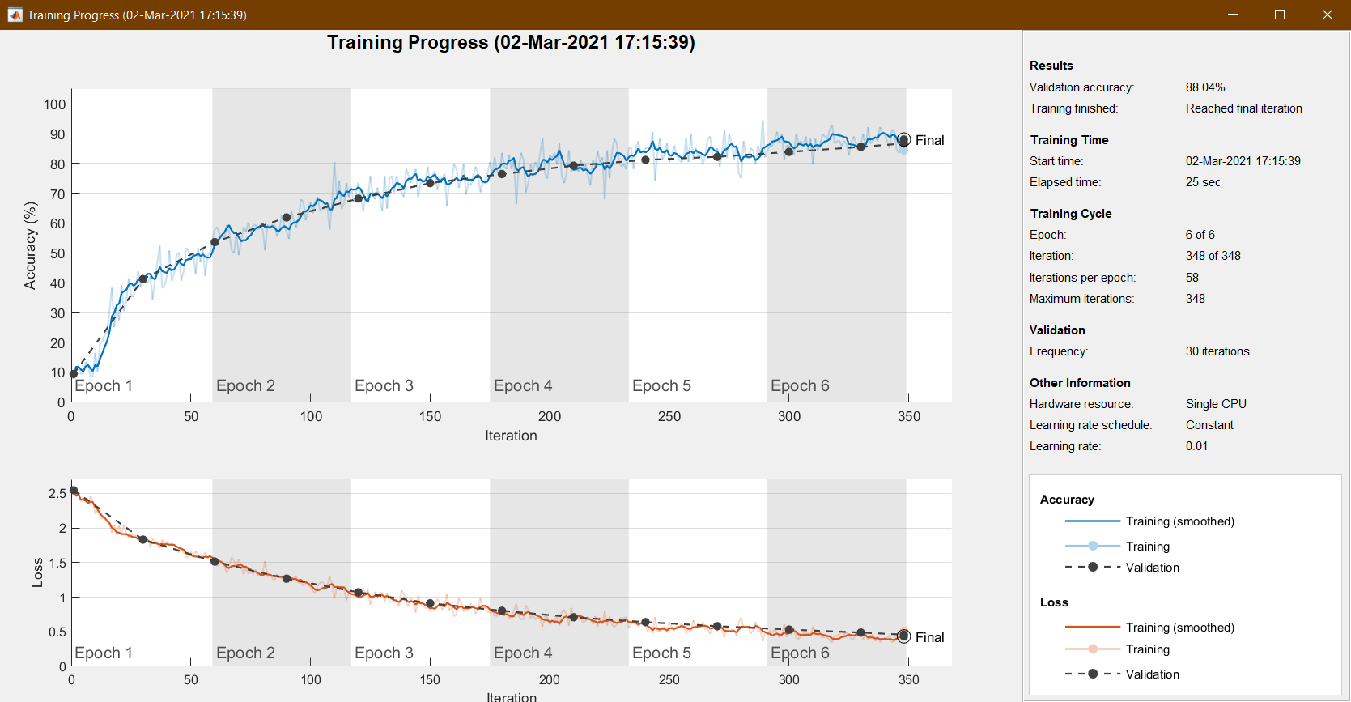

Training results using 2 hidden layers with tanh activation (79.96%):

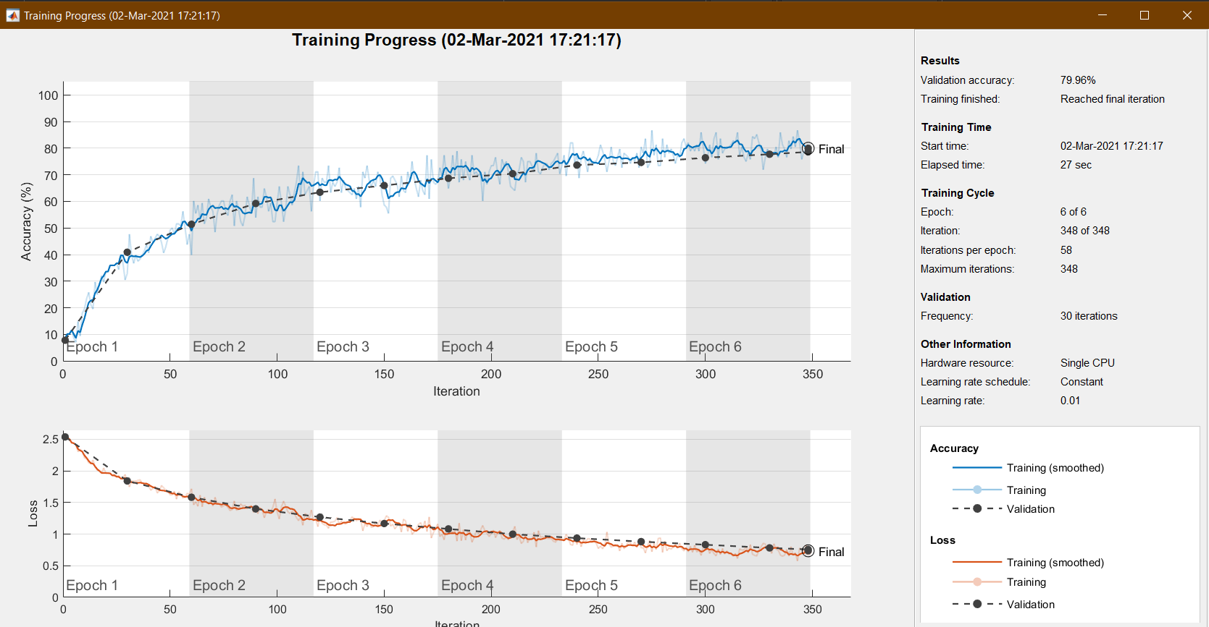

Training results using 2 hidden layers with elu activation (82.28%):

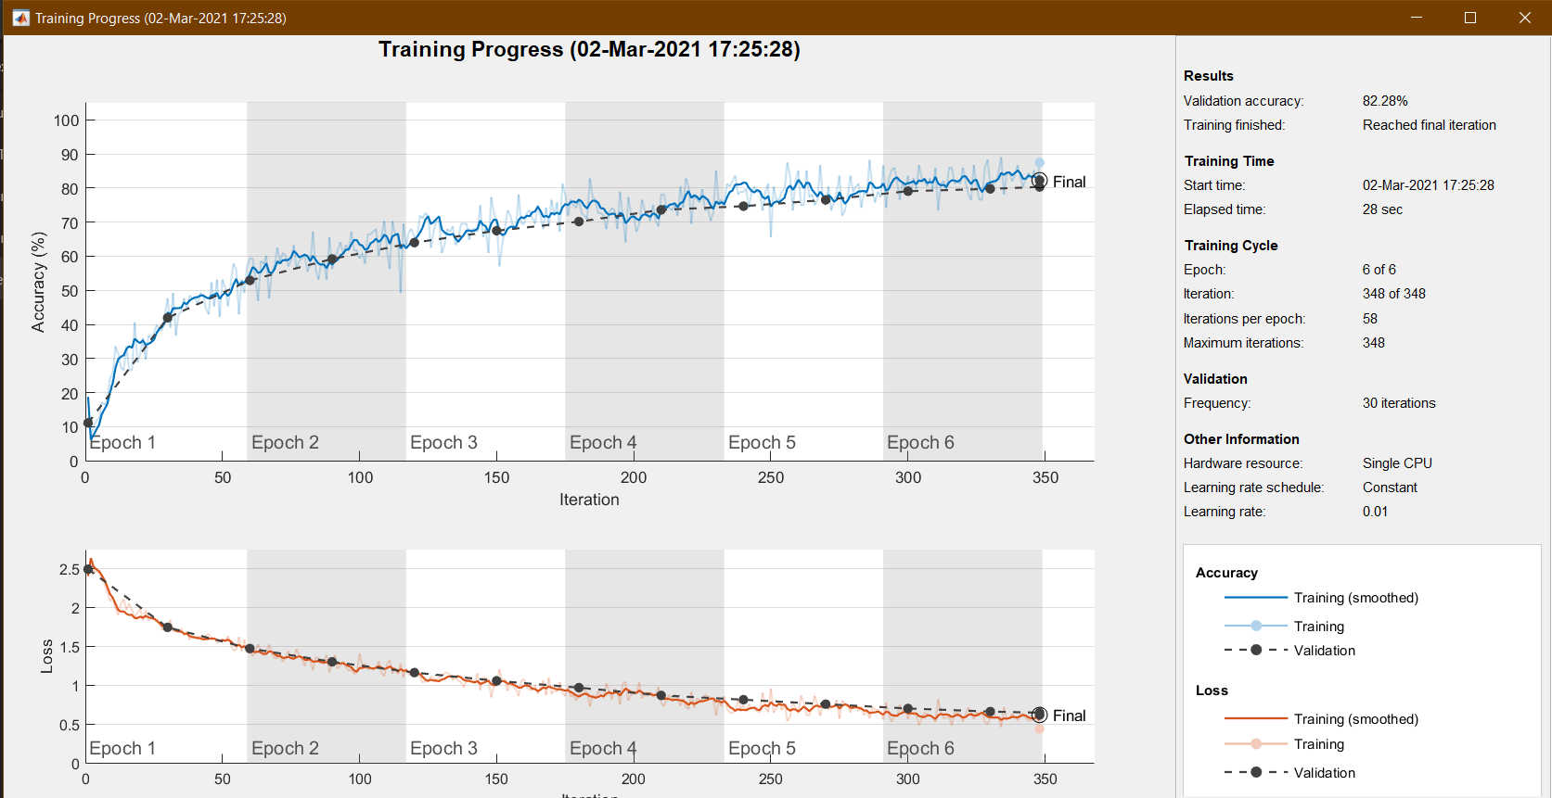

Training results using 2 hidden layers with relu activation (85.20%):

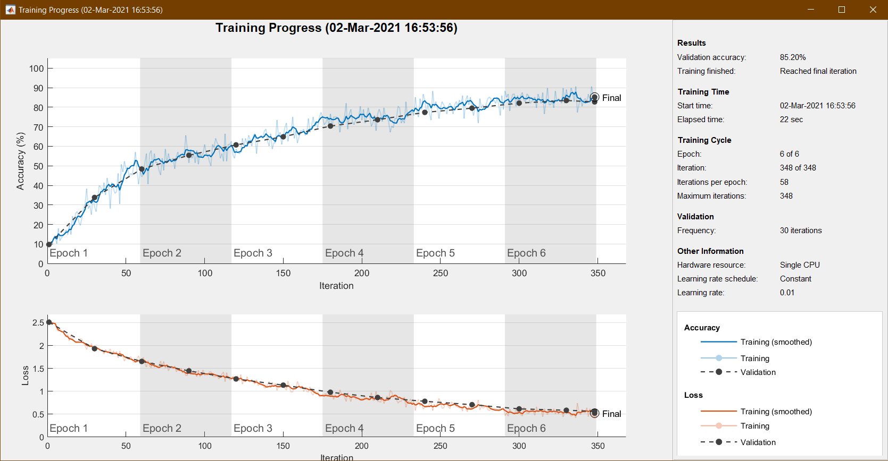

We can conclude from the above four training sessions that using different activation functions in the hidden layers does not significantly affect the training accuracies.

**Modifying number of hidden layers:**

Training results using 3 hidden layers with relu activation (86.68%):

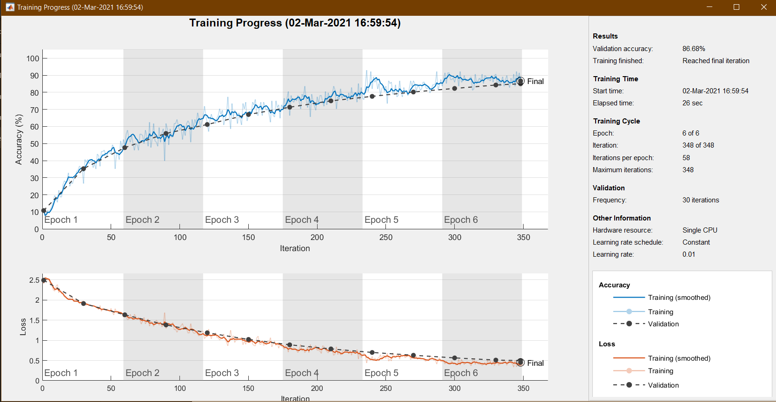

Training results using 4 hidden layers with relu activation (82.16%):

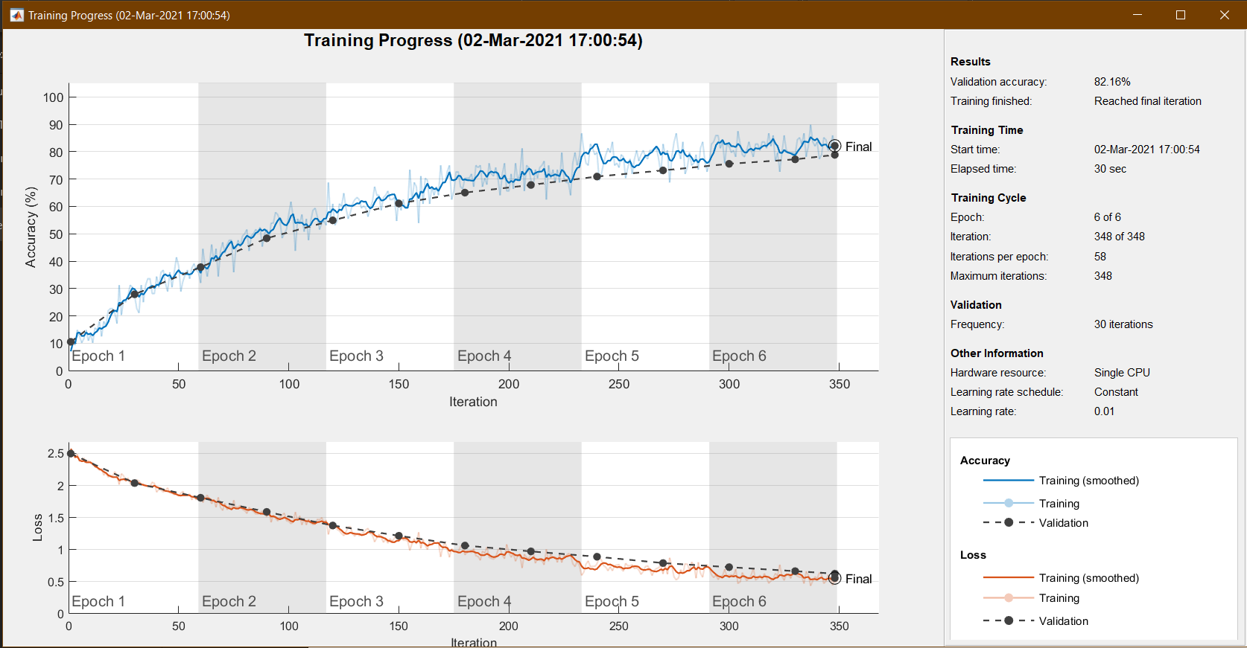

Training results using 5 hidden layers with relu activation (84.36%):

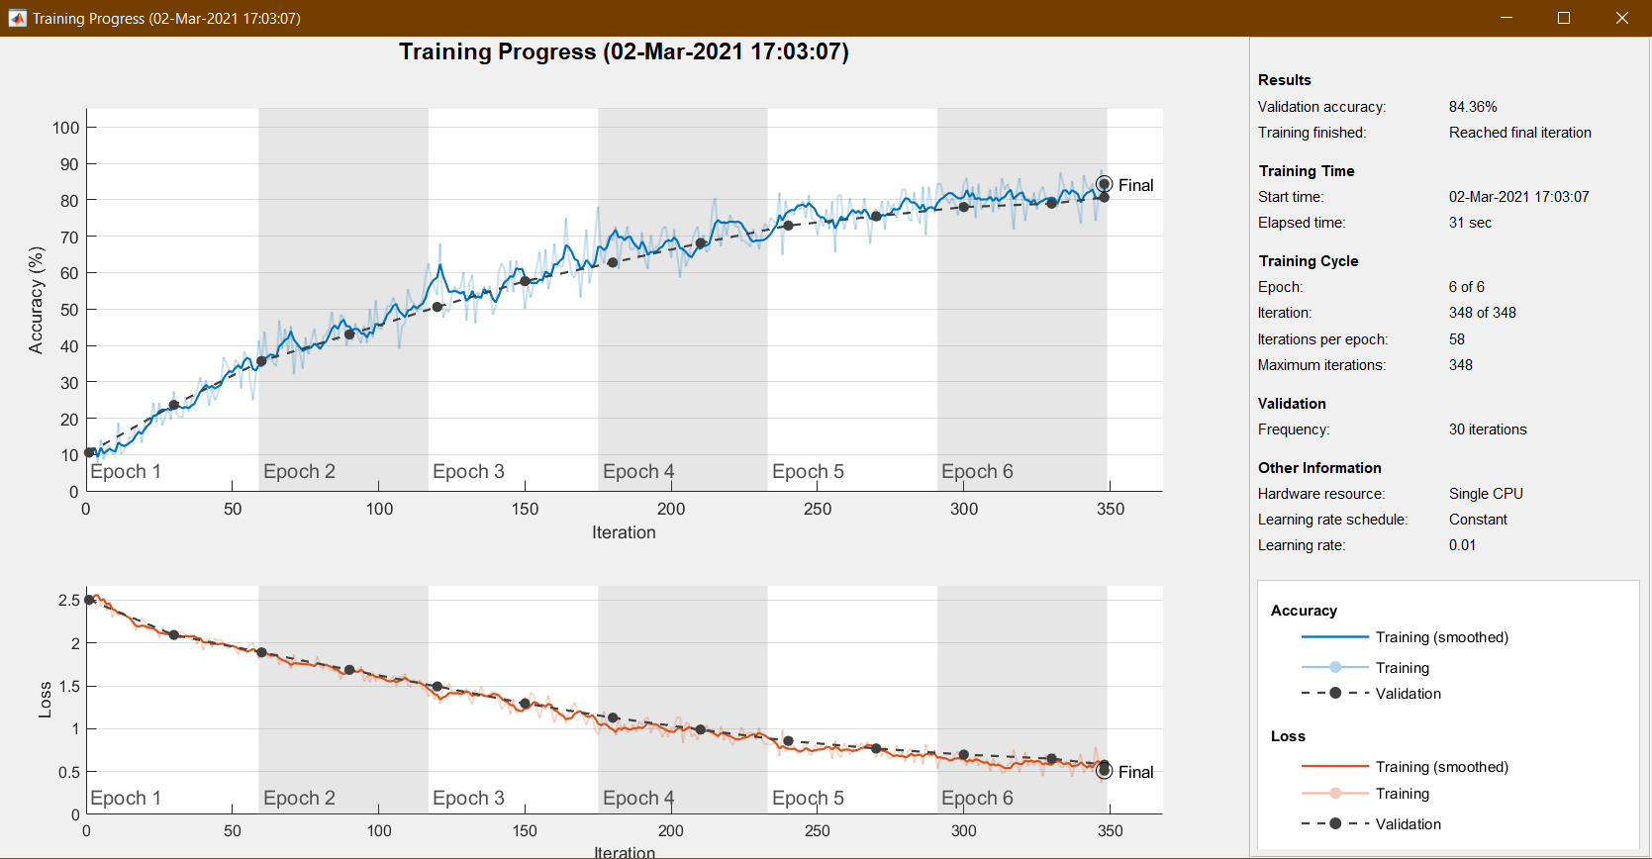

We can conclude from the above three training sessions that adding more layers past the original two does not necessarily yield a higher training accuracy.